**{Banner}**

(shows up at the top of each page)

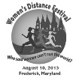

**{Home}**

**Frederick Women’s Distance Festival**

**5k Run/Walk**

**Saturday, August 10, 2013 – 8:00am**

The Frederick Steeplechasers Running club is sponsoring this 5k (3.1 mile) race as part of the 24th annual Women’s Distance Festival Grand Prix Series. The objective of the WDF is to promote the health and wellness of women of all ages and abilities.

Proceeds benefit the Women’s Giving Circle of Frederick County, a local organization providing grants to area non-profit organizations assisting women and children in need.

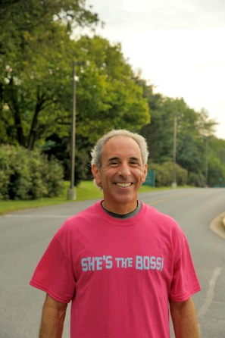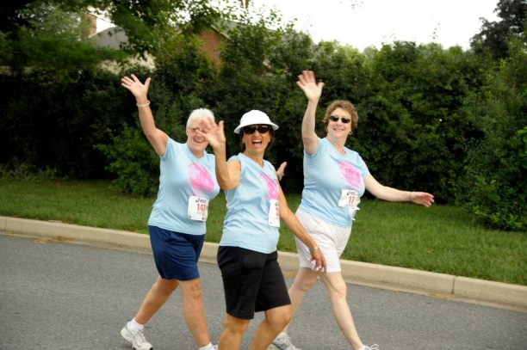

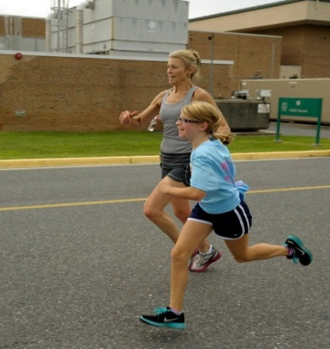

**Who says women can’t run the world?**

**About**

more about [Frederick Steeplechaser Running Club](http://www.steeplechasers.org/)

more about [The Women’s Giving Circle of Frederick County](http://www.womensgivingcircleoffred.org/)

[http://www.steeplechasers.org/msm/images/facebook.jpg](https://www.facebook.com/FrederickWDF)

**{Register}**

<http://www.active.com/running/frederick-md/womens-distance-festival-5k-run-walk-frederick-2013>

**{Race Info}**

**Course**

Scenic two-loop 5K course on FCC’s college campus.

**Start/Finish**

Frederick Community College, 7932 Opossumtown Pike, Frederick, MD 21702

Turn left at the 2nd entrance to FCC –proceed to the Field House.

**Packet Pickup/Late Registration:**

Friday: 3-6pm packet pickup at **If The Shoe Fits,** 1170 W. Patrick St

Race-day: 7:00 am in FCC Field House (race-day registration closes at 7:45)

**Race Fees**

|  |  |  |
| --- | --- | --- |
|  | **Student**  **(under 18)** | **Adult** |
| thru June 30th | $15 | $20 |
| July 1 – August 2nd | $20 | $25 |
| Race Day | $25 | $30 |

**Teams**

Sign up as an individual or as part of a team.

Teams may be registered as:

* mother-daughter
* sister-sister
* aunt-niece
* grandmother/granddaughter
* corporate

**T-Shirts**

Commemorative technical shirts to all pre-registrants. No guarantee of shirts for race-day registrants. *Exchanges after the race, if shirts available*

**Awards Ceremony and Celebration**

Awards to:

* top three overall
* top master
* top three in each age group (under 14, 15-19, 20-24, 25-29, 30-34, 35-39, 40-44, 45-49, 50-54, 55-59, 60-64, 65-69, 70-74, 75-80, and 81+)
* top in each team category

No duplication of prizes.

Random prizes galore!

Post-race refreshments provided.

**{Results}**

Pick up from FSRC website

**{Sponsors}**

**Corporate sponsorships:** We need the support of our community…. Various levels of sponsorship are available promoting your company’s business. Please request a Fact Sheet on sponsorship from Luanne.houck@gdit.com

Prize donations such as vendor gift certificates are greatly appreciated as well for random prize drawings!

As of June 16:

Dr. Elizabeth Liotta, M.D. Dermatologist - Premier tee shirt sponsor  
CORP OHS - Finish line sponsor  
Modern Dentistry - Awards sponsor  
Sue Collins, ReMax Results - Water stop sponsor  
McLaughlin Family Chiropractic - Water stop sponsor  
OBA Bank - Mile marker sponsor  
Riverside Liquors – Mile marker Sponsor  
A.J. Photography - General sponsor  
Drs. Bloom and Reddy - General sponsor  
In-Fit Studio - In-kind sponsor  
  
Sponsorships are still open. Let's make this year's WDF better than ever. All proceeds are going to the Women's Giving Circle, local non-profit helping women and children in Frederick.

**{Contact Us}**

**To Volunteer or for More Information Contact:** Peggy Waxter at 301-663-8082 / email: pwaxter@comcast.net